Cricket Player Performance Tracking

Topic : CRICKSTATS
College :sanghamam college of arts & scince
Department :BCA
Team Name :Cricktats application
Members :annamalai,arunraj,bhuvaneshwari,dhanalakshmi,aranganayagi

Cricket Player Performance Tracking

Application : CRICKSTATS

User Story:

As a Salesforce Admin, I want to create a comprehensive player performance tracking application within Salesforce to capture and analyze detailed match-by-match information of cricket players. This application will include custom objects such as Player and Match Performance with carefully defined fields and relationships to ensure data integrity and accessibility. By leveraging master-detail and lookup relationships, the application will enable robust tracking of individual and team performances, facilitate insightful reporting and analytics, and support the overall management of player statistics, thereby enhancing strategic decision-making and player development initiatives.

1. INTRODUCTION

1.1 Project Overview :

CRICKSTATS is a Salesforce-based application designed to track, manage, and analyze cricket players’ performance on a match-by-match basis. The system uses custom objects, relationships, dashboards, and automation tools to provide structured performance insights.

It enables coaches, analysts, and administrators to record player statistics, generate reports, and support strategic decision-making.

1.2 Purpose :

The main purpose of this project is:

To digitize player performance records

To improve accuracy and accessibility of cricket statistics

To provide real-time analytics

To support player development and team planning

To automate data management using Salesforce

2. IDEATION PHASE

2.1 Problem Statement (Customer Problem Statement Template)

Problem | I am | I’m trying | But | Because | Which
Statement | (Customer) | to |  |  | makes me
(PS) |  |  |  |  | feel
PS-1 | A cricket | Track player | I cannot get | Data is | Frustrated
 | team coach | performance | accurate | stored in | and unsure
 |  | across | statistics | different | about team
 |  | matches | easily | files and | selection
 |  |  |  | formats
PS-2 | A team | Maintain | It takes too | Most | Stressed and
 | manager | complete | much time | records are | inefficient
 |  | player | to update | maintained
 |  | records | and verify | manually
 |  |  | data
PS-3 | A sports | Analyze | I face | There is no | Confused
 | analyst | player trends | difficulty in | centralized | and
 |  | and generate | comparing | analytics | dissatisfied
 |  | reports | performance | system
 |  |  | s

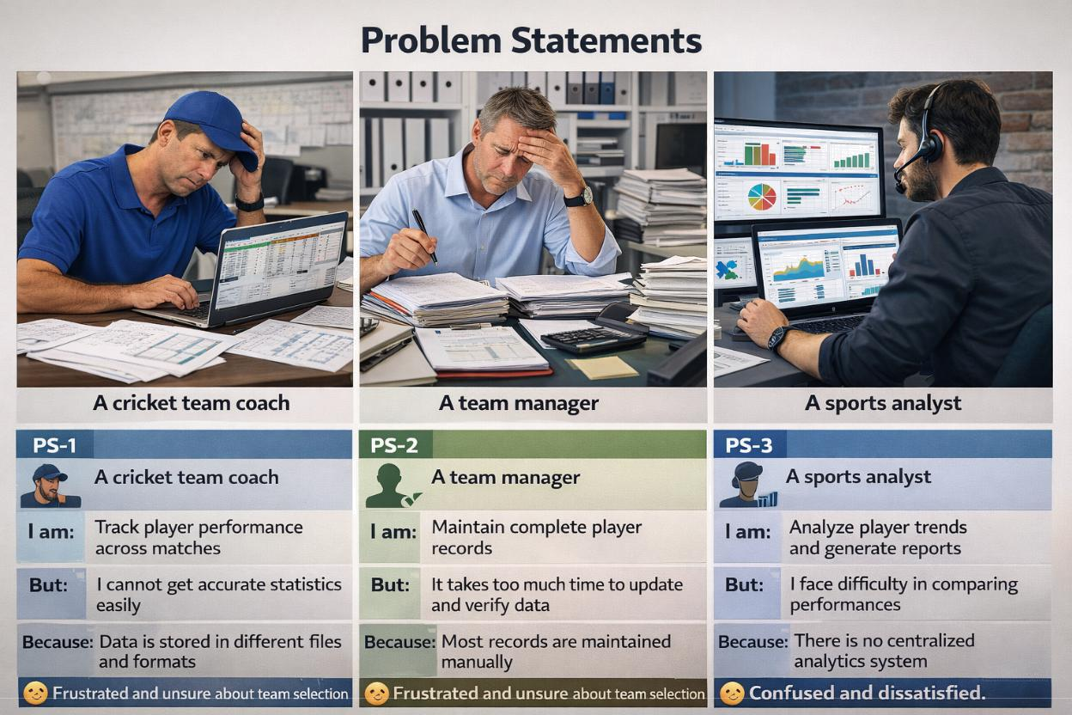

2.2 Empathy Map Canvas

Target Users

●​ Team Managers

●​ Coaches

●​ Analysts

●​ Salesforce Admins

Empathy Analysis

Aspect​ ​ Description

●​ Think & Feel: Need accurate data, better insights

●​ Hear: Feedback from management

●​ See: Multiple data sources

●​ Say & Do: Collect statistics manually
●​ Pain: Data errors, delays

●​ Gain: Faster decisions, automation
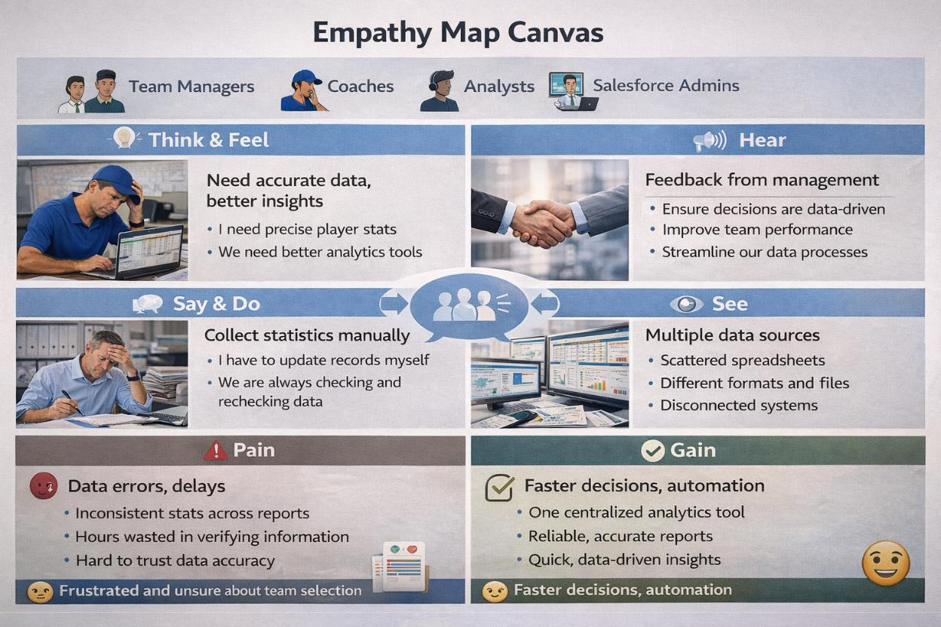

2.3 Brainstorming

Brainstormed Ideas

●​ Web-based player management system

●​ Mobile statistics tracker

●​ Salesforce-integrated CRM

●​ AI-based performance prediction

●​ Dashboard-based analytics

Selected Idea: Salesforce-based performance tracking platform (CRICKSTATS)
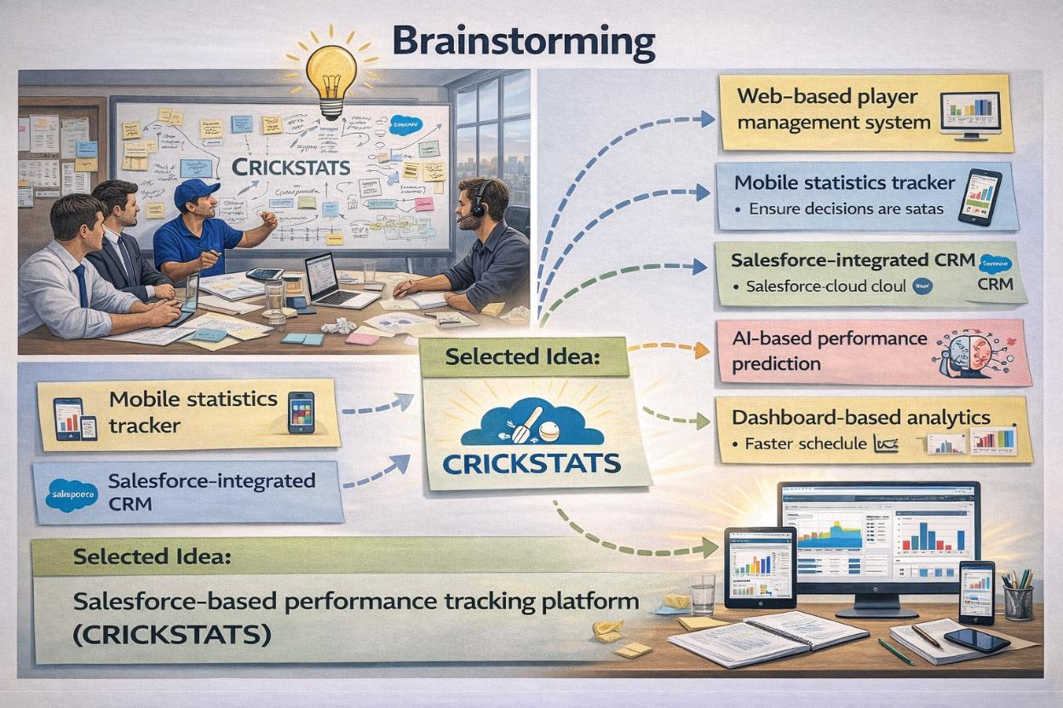

3.REQUIREMENT ANALYSIS PHASE

3.1 Customer Journey Map

Journey Stages:

●​ Login

●​ Enter Player Data

●​ Record Match Performance

●​ Generate Reports

●​ Analyze Results

●​ Decision Making
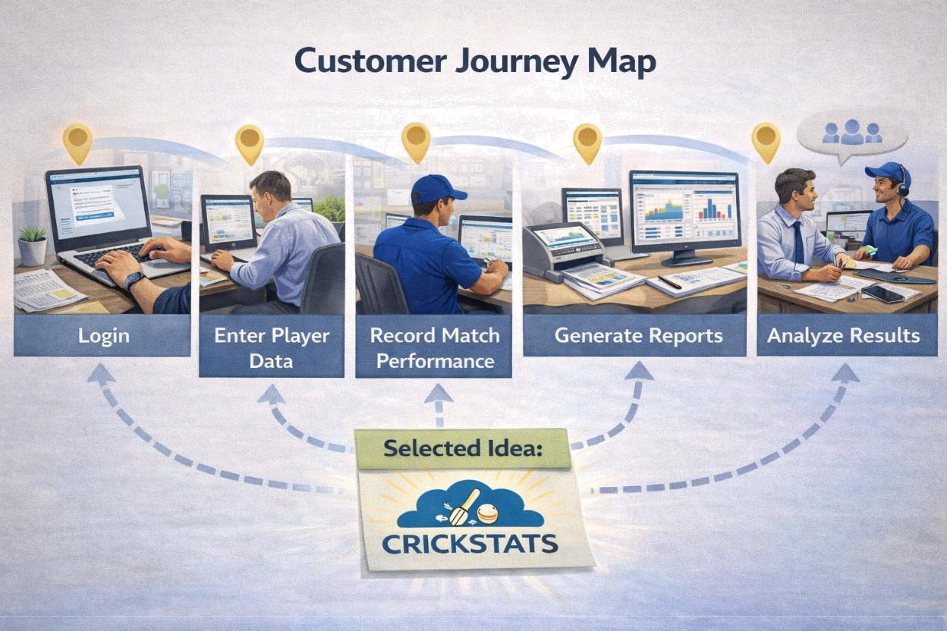

3.2 Solution Requirements

Functional Requirements

FR No | Requirement
FR-1 | Player Registration
FR-2 | Match Performance Entry
FR-3 | Dashboard Generation
FR-4 | Report Creation
FR-5 | Flow Automation

Non-Functional Requirements (NFRs) – CRICKSTATS

NFR-1: Usability

The system should be easy to understand and use by coaches, managers, analysts, and admins without requiring technical training.

Requirements

●​ Simple and intuitive user interface

●​ Clear navigation menus

●​ Easy-to-read dashboards

●​ Minimal learning curve

Examples:

●​ A new coach should be able to:

●​ Log in

●​ Enter match data

●​ View player reports

●​ within a few minutes without special training.

Example: The Salesforce Lightning interface provides drag-and-drop dashboards and user-friendly forms.

NFR-2: Security

The system must protect sensitive player data from unauthorized access.

Requirements

●​ Role-based access control

●​ Secure authentication

●​ Encrypted data storage

●​ Regular backups

.
Examples:

●​ Coaches can view player statistics

●​ Managers can edit records

●​ Analysts can generate reports

●​ Only admins can modify system settings

Example: Salesforce Profiles and Permission Sets restrict access to confidential information.

NFR-3: Reliability

The system should function correctly without failure and store data accurately.

Requirements

●​ No data loss

●​ Automatic backups

●​ Error handling

●​ System stability

Example:

If a manager enters match statistics and loses internet connection, the data should be saved automatically when reconnected.

Salesforce cloud backup ensures recovery in case of system failure.

NFR-4: Performance

The system should respond quickly and handle large volumes of data efficiently.

Requirements

●​ Fast page loading

●​ Quick report generation

●​ Smooth dashboard rendering

●​ Minimal response time
Example:

When an analyst generates a performance report for 100+ players, the report should load within 2–3 seconds.

Optimized Salesforce queries and caching improve response speed.

NFR-5: Availability

The system should be accessible whenever users need it.

Requirements

●​ 24/7 system availability

●​ Minimal downtime

●​ Cloud-based access

●​ Disaster recovery

Example:

Coaches should be able to access CRICKSTATS even during tournaments at night or on weekends.

Salesforce provides high uptime with cloud hosting.

NFR-6: Scalability

The system should support increasing numbers of users, players, and records.

Requirements

●​ Handle growing datasets

●​ Support more teams and leagues

●​ Expand storage capacity

●​ Maintain performance under load

Example:
If CRICKSTATS is extended from one team to 50 teams, the system should still perform smoothly.

Salesforce cloud infrastructure automatically scales storage and processing.

3.3 Data Flow Diagram

Data Flow

User → Salesforce UI → Player Object → Match Performance → Reports → Dashboard
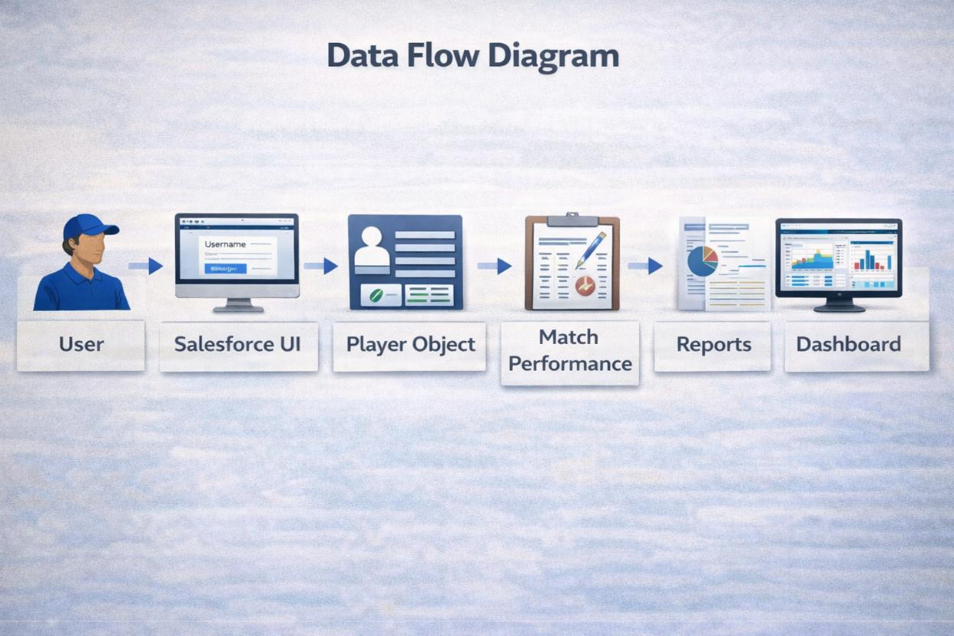
3.4 Technology Stack

Layer | Technology
Frontend | Salesforce Lightning
Analytics | Reports & Dashboards
Automation | Salesforce Flows
Backend | Salesforce Objects
Database | Salesforce Cloud

4. PROJECT DESIGN PHASE

4.1 Problem–Solution Fit

The CRICKSTATS system effectively addresses the key challenges faced in traditional cricket performance management. Earlier, most player and match data were maintained using manual records, which were time-consuming and prone to errors. This issue has been resolved by implementing an automated system through Salesforce, which ensures accurate and efficient data entry and management. The problem of data loss, caused by improper storage and lack of backups, is overcome by using secure cloud storage that safely stores all information and allows easy retrieval. Poor analysis of player performance, due to scattered and unorganized data, is addressed through interactive dashboards that present clear visual insights and reports. Additionally, delays in accessing performance information and generating reports are eliminated by providing real-time reporting features, enabling users to make faster and more informed decisions. Thus, CRICKSTATS successfully bridges the gap between existing problems and modern technological solutions.
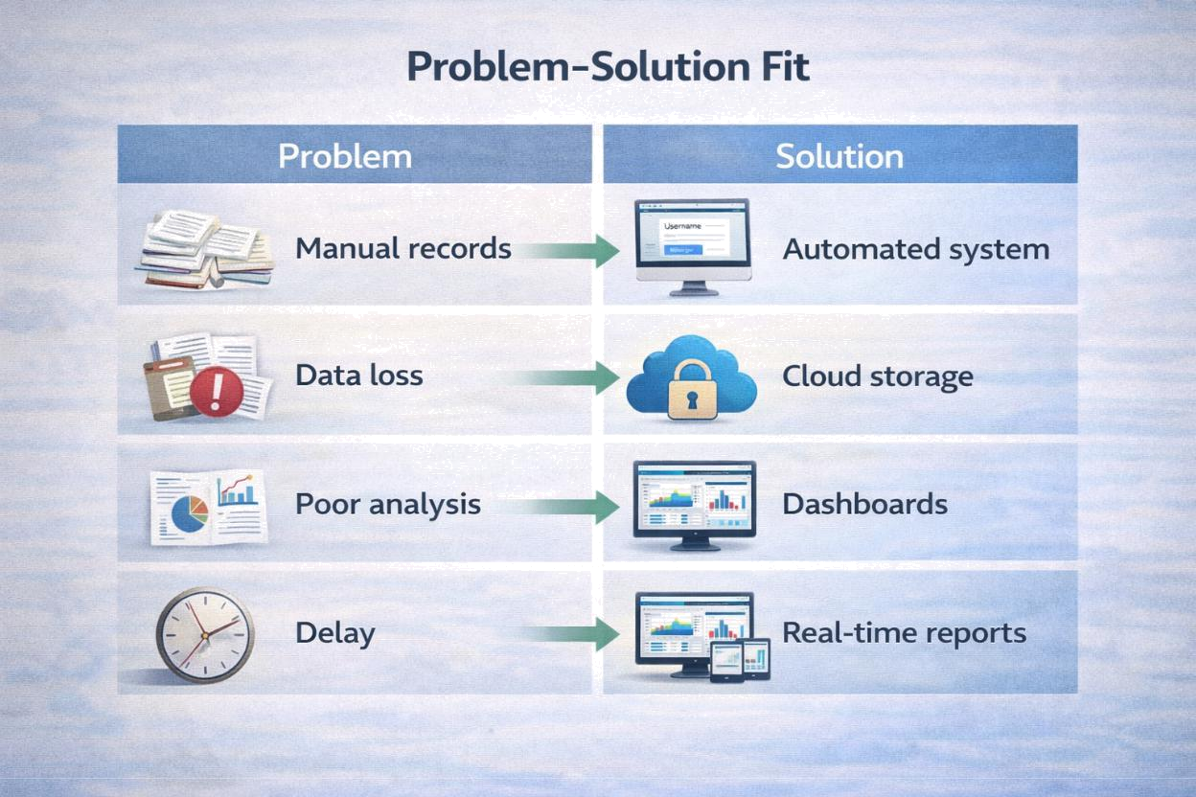

4.2 Proposed Solution

Description

CRICKSTATS provides:

●​ Custom objects (Player, Match Performance)

●​ Master-detail relationships

●​ Roll-up summaries

●​ Lightning App

●​ Automated flows

●​ Interactive dashboards

Key Features

●​ Centralized database

●​ Live statistics

●​ Secure access
●​ Scalable design

●​ Easy reporting

4.3 Solution Architecture

Architecture Layers

●​ Presentation Layer (Lightning UI)

●​ Application Layer (Flows, Logic)

●​ Data Layer (Objects)

●​ Analytics Layer (Reports)
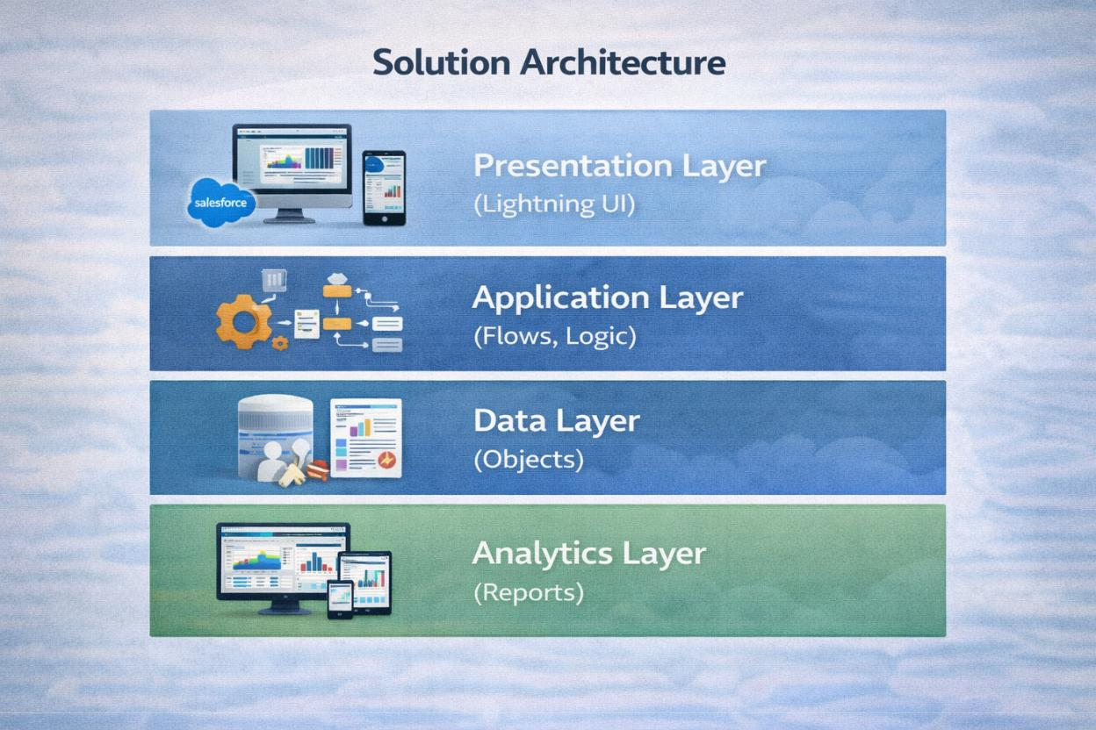
5. PROJECT PLANNING & SCHEDULING

5.1 Project Planning

●​ Agile-based execution

●​ Object creation → automation → reporting

●​ Sprint-wise development

Product Backlog, Sprint Schedule, and Estimation (4 Marks)

Use the below template to create product backlog and sprint schedule

Sprint | Functional | User | User Story / Task | Story | Priority | Team
 | Requirement | Story |  | Points |  | Member
 | (Epic) | Number |  |  |  | s
Sprint-1 | Developer | USN-1 | As an admin, I want to create a | 1 | High | Member1
 | Setup |  | Salesforce developer account so
 |  |  | that I can configure and deploy the
 |  |  | CRICKSTATS system.
Sprint-1 | Data Modeling | USN-2 | As an admin, I want to create | 3 | High | Member2
 |  |  | Player and Match Performance
 |  |  | objects so that player and match
 |  |  | data can be stored systematically.
Sprint-2 | Navigation | USN-3 | As a user, I want separate tabs for | 3 | High | Member3
 |  |  | each object so that I can easily
 |  |  | navigate and manage records
 |  |  | within the application.
Sprint-2 | UI Design | USN-4 | As a coach, I want a dedicated | 3 | High | Member4
 |  |  | Lightning App so that all
 |  |  | performance tracking features are
 |  |  | accessible from one dashboard.
Sprint-2 | Data Structure | USN-5 | As an admin, I want to create | 5 | Medium | Member1
 |  |  | player and match fields so that
 |  |  | complete performance details can
 |  |  | be captured accurately.
Sprint-2 | Data Structure | USN-6 | As a user, I want customized page | 5 | High | Member2
 |  |  | layouts so that only relevant fields
 |  |  | are displayed during data entry.
Sprint-2 | Automation | USN-7 | As a system, I want to validate | 3 | High | Member4
 |  |  | player and match inputs so that
 |  |  | incorrect data entries are
 |  |  | prevented.
Sprint-3 | Automation | USN-8 | As a system, I want automated | 5 | High | Member1
 |  |  | flows to update player statistics so
 |  |  | that performance data remains
 |  |  | accurate.

Project Tracker, Velocity & Burndown Chart: (4 Marks)

Sprint | Total Story | Duratio | Sprint Start |  | Sprint End Date |  | Story Points | Sprint Release
 | Points | n | Date |  | (Planned) |  | Completed | Date (Actual)
 |  |  |  |  |  |  | (as on
 |  |  |  |  |  |  | Planned End
 |  |  |  |  |  |  | Date)
Sprint-1 | 20 | 6 Days | 24 | Oct 2022 | 29 | Oct 2022 | 20 | 29 Oct 2022
Sprint-2 | 20 | 6 Days | 31 | Oct 2022 | 05 | Nov 2022
Sprint-3 | 20 | 6 Days | 07 | Nov 2022 | 12 | Nov 2022
Sprint-4 | 20 | 6 Days | 14 | Nov 2022 | 19 | Nov 2022

6. Functional & Performance Testing:

In this project we have to create a 6 moduels , they are

1)Home 1
2)players
3)Match performance
4)Reports
5)Dashbords
6)Home

1)Home 1

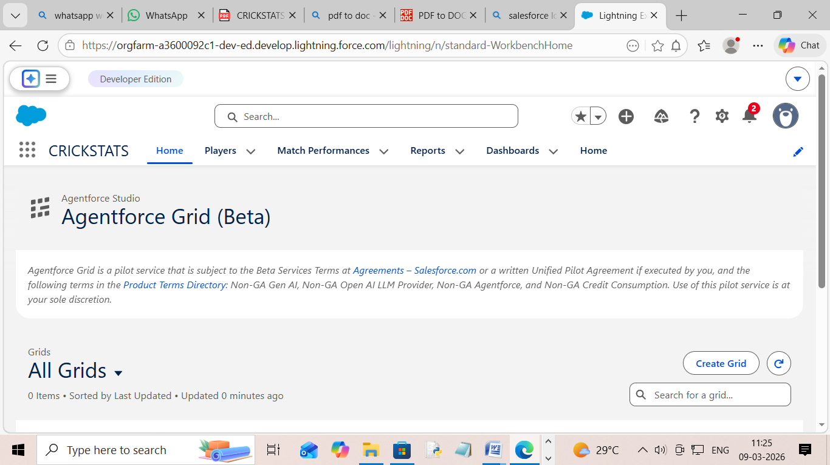

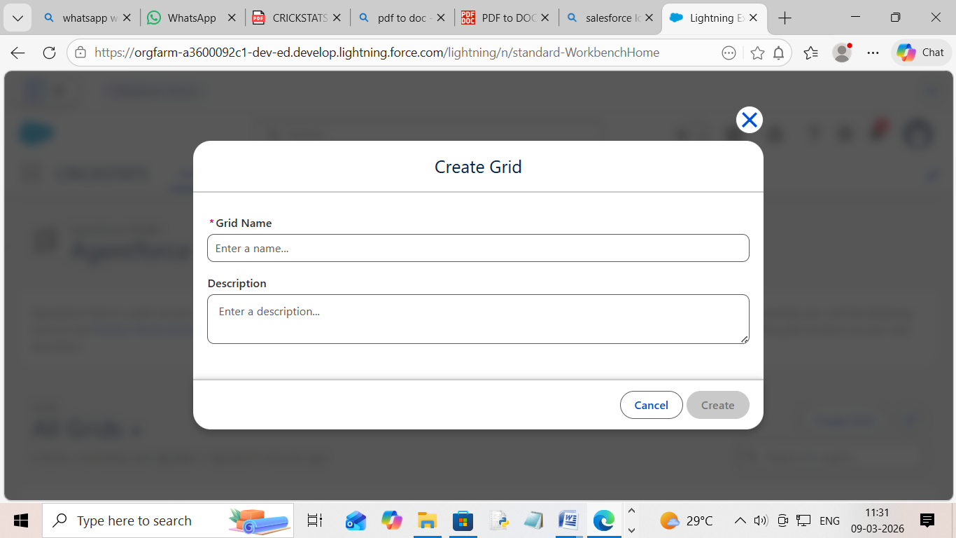

2)players

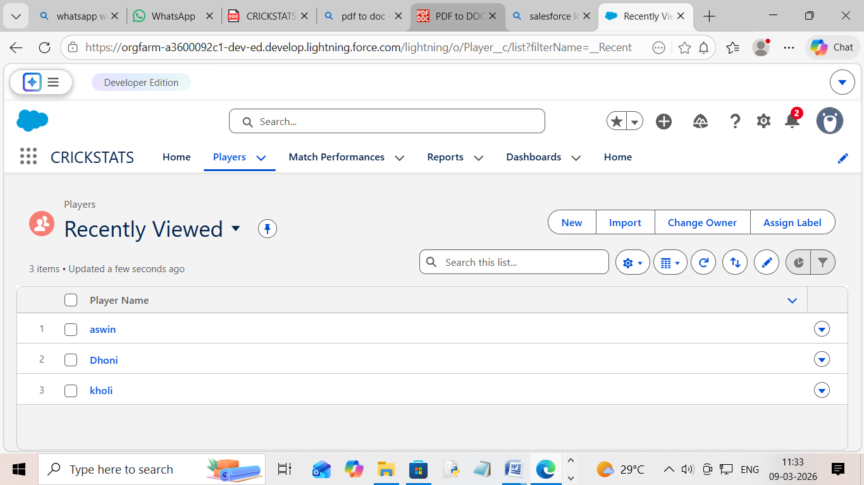

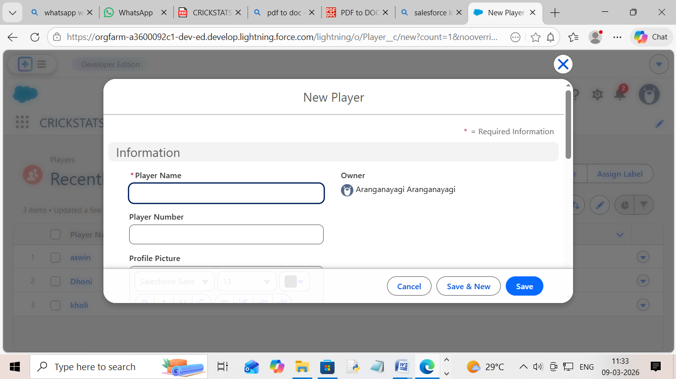
3)Match performance

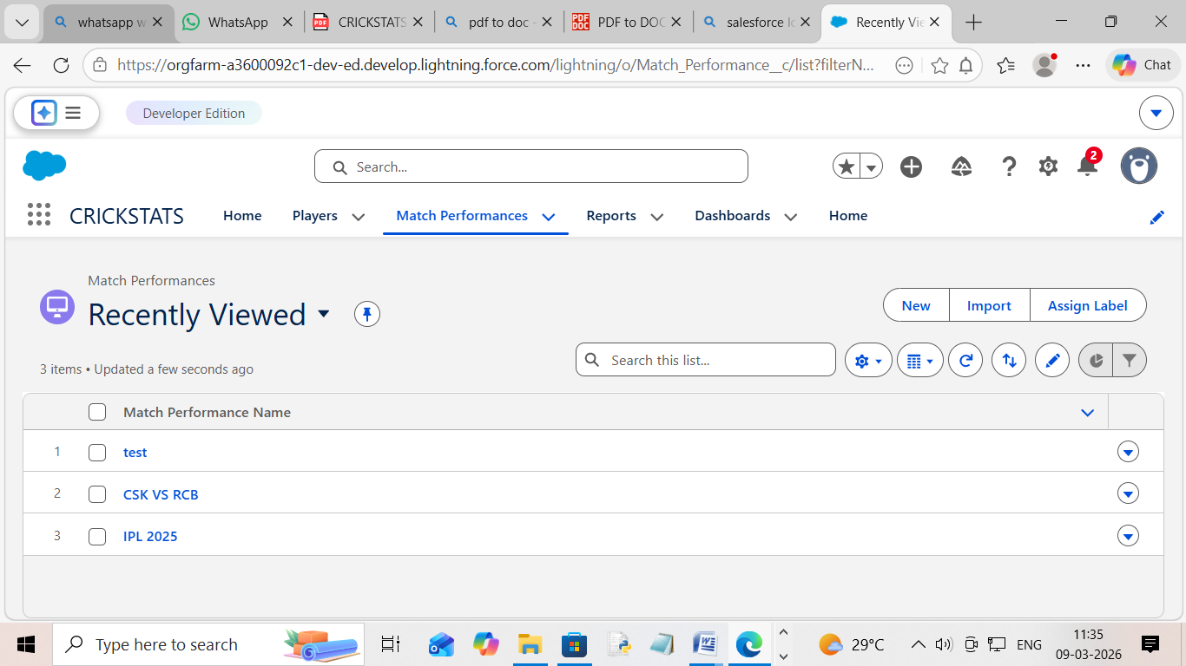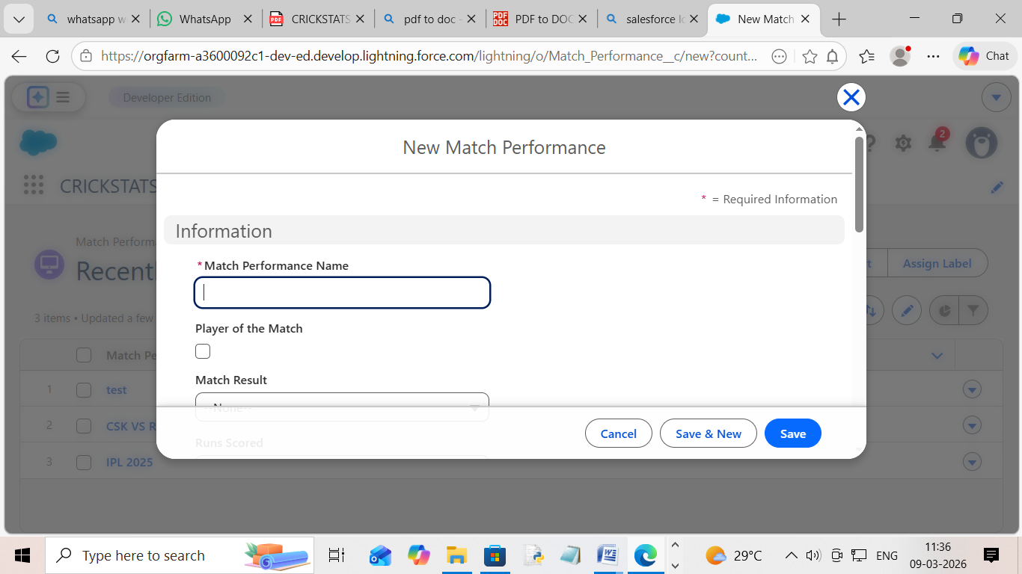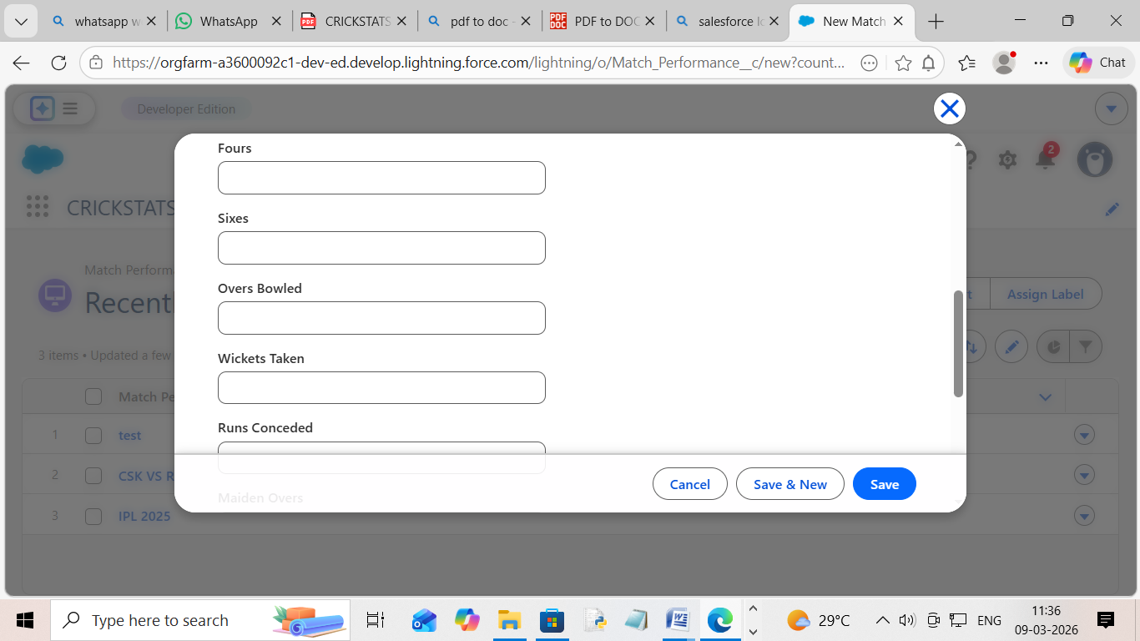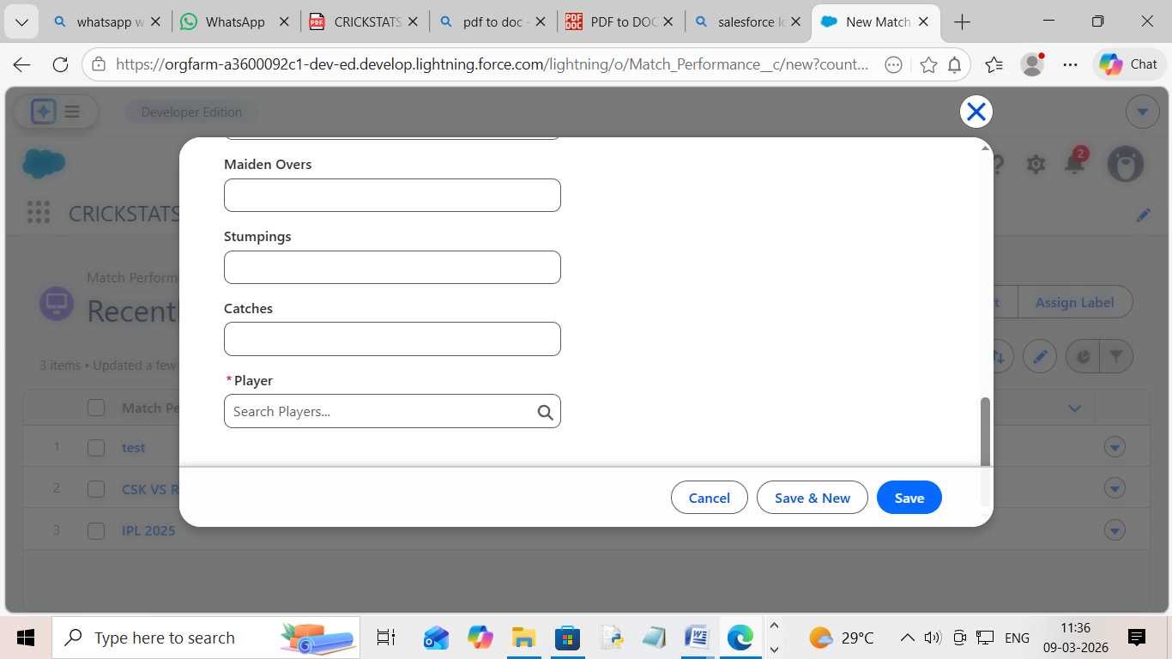

4)Reports
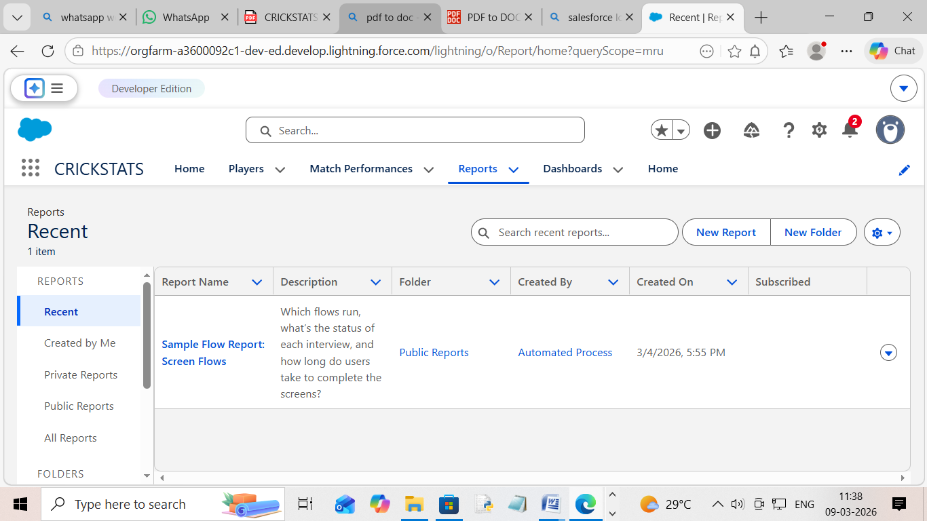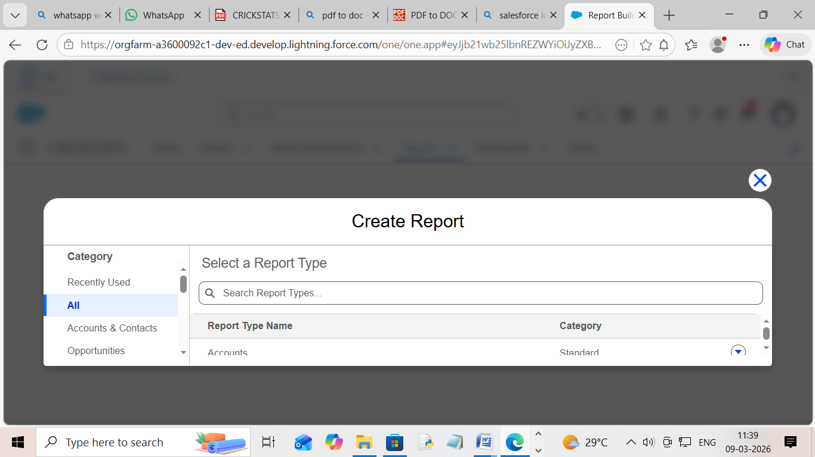

5)Dashbords

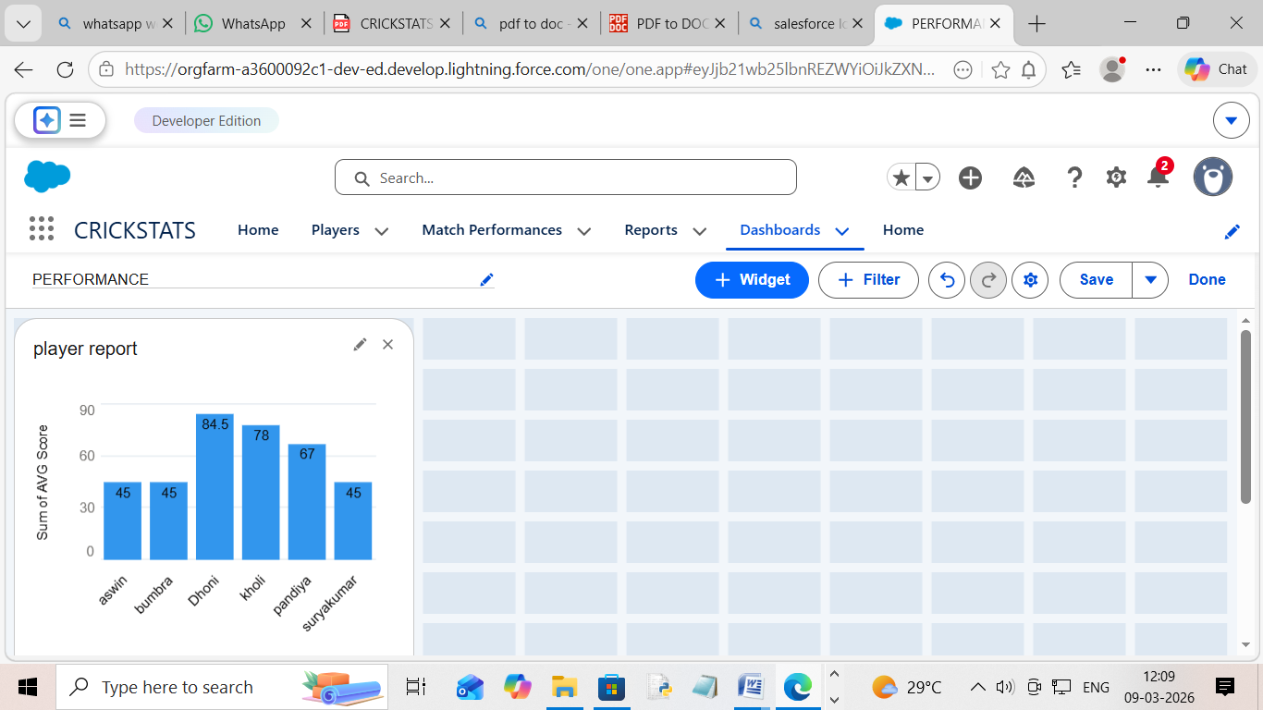

6)Home

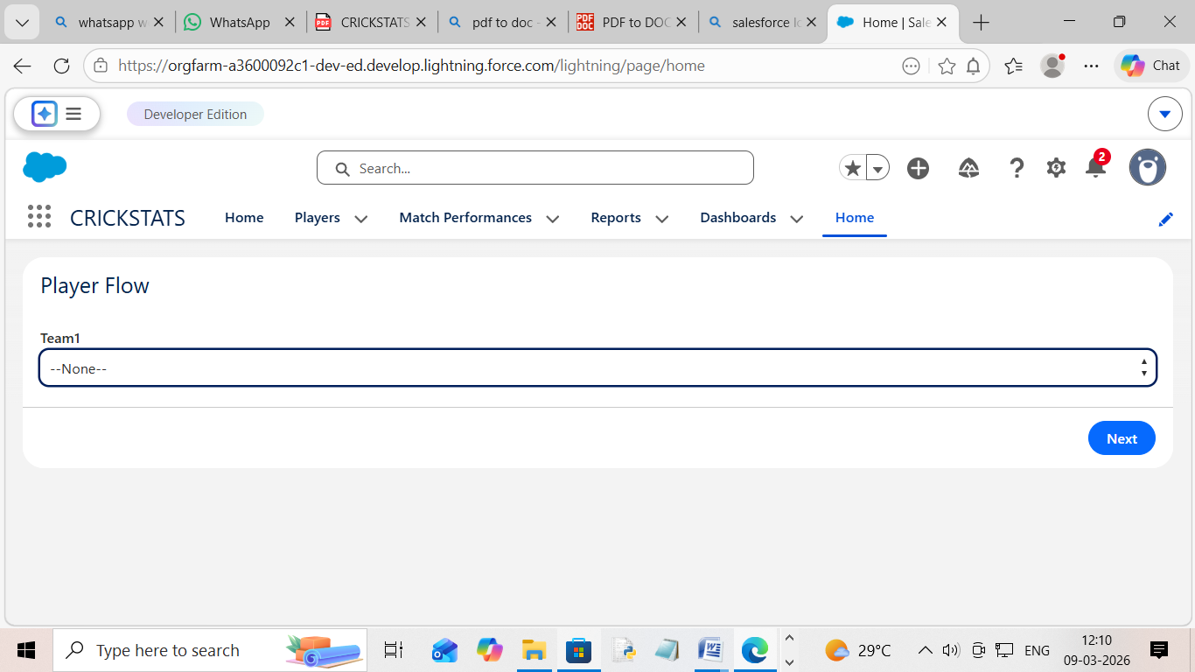

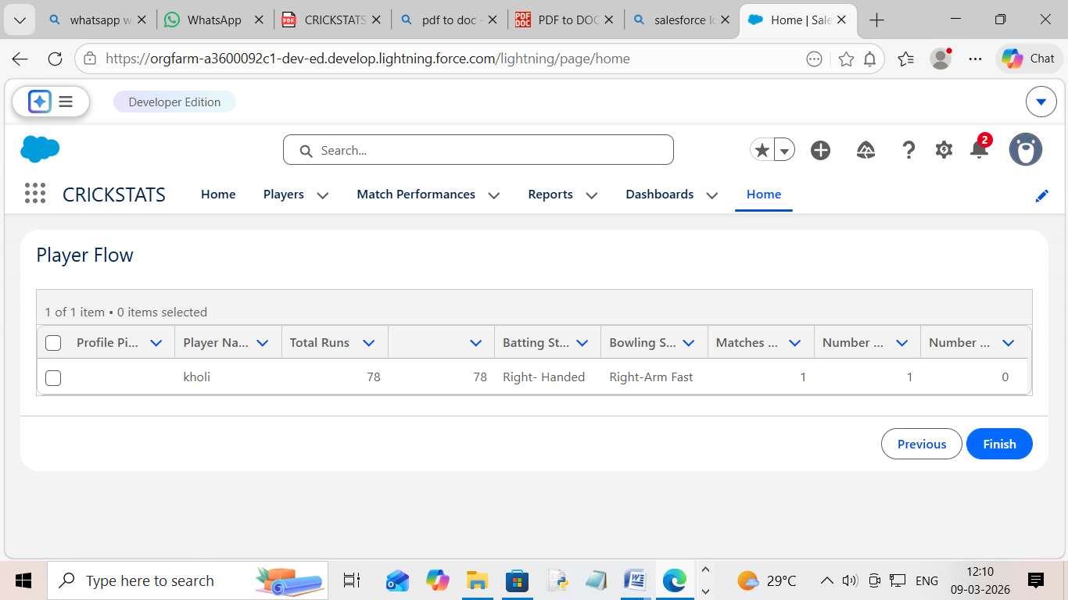

7) Conclusion:

CRICKSTATS successfully implements a cloud-based cricket performance tracking system using Salesforce. The system automates data management, improves reporting accuracy, and supports informed decision-making. The project demonstrates practical application of SDLC, Agile methodology, and CRM-based development.

Thank You

